**INFORMED consent PATIENT**

Donor Search

Patient Data

Surname:  First name:

Date of birth (dd/mm/yyyy):

You need blood stem cells from an unrelated donor for the purpose of treating your illness.

There are people all over the world who have joined one of the circa 100 “donor registries”, declaring their willingness to donate blood stem cells.

Data relating to you – meaning, your surname, first name, sex and date of birth as well as data on your state of health and tissue markers – is required for the search for a suitable blood stem cell donor in Switzerland or another country

* Swiss Transfusion SRC is subject to the Swiss Federal Act on Data Protection (FADP). My data will be processed in Switzerland.
* After a transplant procedure, my data will be stored in accordance with the legal requirements
* For the purposes of an international search for an unrelated donor of bone marrow or of peripheral blood stem cells or for a cord blood unit, my data will be sent to foreign donor registries, i.e. including to countries that do no not have data protection legislation comparable to that of Switzerland and where data protection is not ensured to the same degree
* Should I have concerns about my data being transmitted to a certain country, I can discuss these with my doctor before the donor search starts
* I have the right to request the transplant centre to inform me, at any time, about the stored data concerning me. If I do so, the transplant centre must notify me of all data concerning me contained in a data file
* My right to have my data deleted is restricted due to the medical necessity to ensure traceability and the necessity to collect certain data for transplantation-safety purposes (monitoring of risks and traceability)

I consent to the use of the personal data relating to me named above for the national and international search for an unrelated donor of bone marrow or of peripheral blood stem cells or for a cord blood unit, and I consent to the required transmission of data to other countries.

Date and signature of patient or of the legal representative:

Date:  Signature:

Legal representative’s name / relationship to patient

Data protection provisions

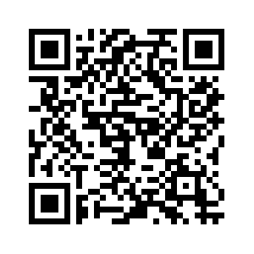

Further information:

<https://www.blutstammzellspende.ch/de/datenschutz-blutstammzellspende>