Donor Information Follow Up and Informed Consent for Transmission of Data to the EBMT Database

NAME: FIRST NAME:

RELATED ID:

I have decided to donate blood stem cells/lymphocytes for a patient needing transplantation.

The Ordinance on the Transplantation of Human Organs, Tissues and Cells requires all bone marrow and peripheral blood stem cell donors in Switzerland to receive regular follow-up for 10 years. According to Swiss Blood Stem Cells/Swiss Transfusion SRC regulations, this also applies to lymphocyte donation (DLI).

Various cell harvest and follow-up data relating to all donors need to be collected in pseudonymised form (name replaced by a multidigit combination of letters or numbers) for later evaluation. These data may be accessed and reviewed by the Federal Office of Public Health. All persons authorised to do so are bound by the professional duty of confidentiality.

In addition, some of these data are shared with an international registry and entered into a database: the transplant registry of the European Group for Blood and Marrow Transplantation (EBMT). The data collected in the EBMT database are accessible only to medical professionals and registry employees, all of whom are bound by the professional duty of confidentiality. The data include donor number, gender, date of birth, donor health status, and details of the cell harvest and any adverse reactions.

Information on the transmission of personal data: starting from the sixth month after the donation, Swiss Blood Stem Cells (SBSC), a department of Swiss Transfusion SRC, follows up with donors via questionnaire and/or telephone. In order to send me the questionnaire or contact me by phone, SBSC needs personal data relating to you: specifically, your surname, given name, mailing address, telephone number and e-mail address.

Swiss Transfusion SRC is subject to the Swiss Federal Act on Data Protection (FADP). More information on data protection is available at www.blutstammzellspende.ch/de/datenschutz-blutstammzellspende (QR Code: see below). Questions on this topic can be addressed to datenschutz@blutspende.ch at any time.

- I have read the information and understood its contents
- I had ample opportunity to ask questions and my questions were answered to my satisfaction
- I consent to my pseudonymised data being forwarded to the EBMT registry
- I consent to my anonymised data being used for scientific analysis with a view to the improvement and safety of donation and transplantation

Municipality, date: | Further information on the data protection provisions:
Signature of the donor:  (In the case of minor donors, “donor” is intended as a placeholder for “legal representative”.) | 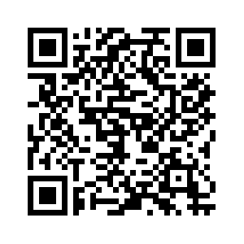 | www.blutstammzellspende.ch/de/datenschutz-blutstammzellspende

